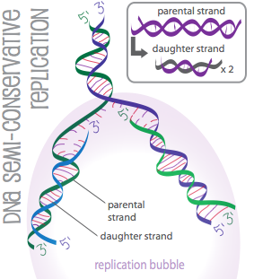
Alina Larson
Rosalee Nguyen
July 8, 2010
Take-home 3
(1.)

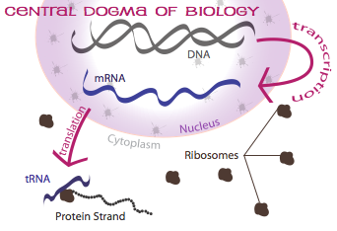
When a DNA molecule replicates itself, the enzyme helicase splits the molecule in two by creating a bubble. Next, RNA primase starts building new DNA strands off of the old ones, in the 5’ to 3’ direction (3’ to 5’ if you’re using the old strands as point of reference), and RNA polymerase comes in to build off of these starter strands… Polymerase leaves some gaps, however, so RNA primase has to come back and fill these holes — also called “Okazaki Fragments” — and eventually the replication is done! What’s left of the original DNA molecule is now two identical daughter DNA molecules, each with one strand from their parent molecule, and one new enzyme-synthesized strand — hence the name “semi-conservative” for this replication process.
(2.)

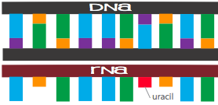
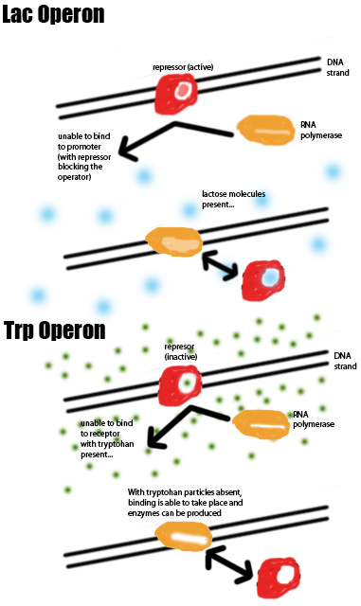
The Central Dogma of Biology is the principle, central to biology (study of life), that explains how DNA and, specifically, the nucleotides it is composed of — adenine, thymine, guanine, and cytosine — are transcribed by messenger RNA as a single strand composed of the same nucleotides, with uracil replacing thymine. If the DNA belongs to a eukaryotic cell, the RNA transcript will have a cap and tail, and unnecessary sequences of genes known as ‘introns’ are cut, leaving only the genetically expressible ‘extrons.’ However, in a prokaryotic cell, these minor deletions do not take place. Instead, you would have the very simple DNA → mRNA → Protein process described in the above picture. Next, for both types of cells, the mRNA exits the cell through the nuclear pores to come in contact with some ribosome in the Endoplasmic Reticulum of the Cytoplasm of the cell. Here, an initiator transfer RNA will settle in the A site of the ribosome and find a starting point from which to start reading the nucleotide bases as codons (in clusters of three). The next tRNA comes in when the first one has located the ‘start’ codon, replacing it in the A site and taking it’s starter amino. This process continues, with one tRNA replacing another as their amino chain gets longer and longer. Eventually the whole RNA strand has been translated and the polypeptide strand can break off from the ribosome to be packaged and sent on its way. DNA never even has to leave the nucleus, and this is what makes this process so beautiful. To avoid damage, DNA is treated as the most precious of documents, from which copies are made and read in their turn.
(2.)

Gene regulation is the ability of a living organism to turn on or off specific genes. It is highly advantageous to an organism to be able to regulate itself, in order to express proteins when needed, so these organisms have been among the most successful.
The lac operon (named for lactose) is a cluster of genes related to the production of enzymes in bacteria such as E. Coli. When there is no lactose present in the cell, a protein called a repressor sits on the operator of a DNA strand, just before the operon (genetic sequence coding for lactose-eating enzyme production), thereby blocking DNA polymerase from binding onto its promoter site (start point) and disabling enzyme production. When lactose appears in the system, a lactose molecule will bind onto the repressor and carry it off, leaving the promoter site free for DNA polymerase to do its work and enzyme production to begin.
The trp operon is very similar, also found in bacteria such as E. Coli, except that it works in the opposite way. When tryptohan is present, the repressor is active. When absent, DNA polymerase is able to do its work.
There are some differences between eukaryotic and prokaryotic cells when it comes to gene regulation. Eukaryotes, being more complex, are able to have individual promoters, and don’t need to have their genes necessarily organized into groups of operants. Prokaryotes are simpler in this respect, having fewer proteins, and more repressors than activators. Both have working systems, however. Each suited to its purpose.
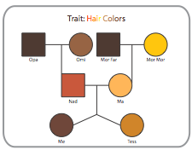
(4.)

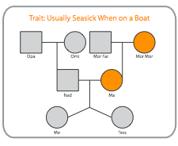
My Family Pedigrees

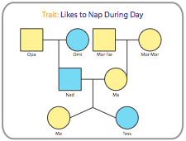
Orange = Usually Seasick
Grey = Not
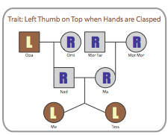

Blue = likes to nap
Yellow = doesn’t

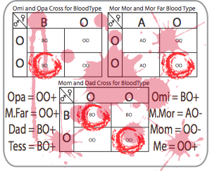
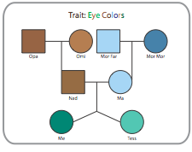

R e s o u r c e s :

DNA REPLICATION:

Textbook, Lecture Notes

http://library.thinkquest.org/C006188/basics/replication.htm

http://employees.csbsju.edu/hjakubowski/classes/chem%20and%20society/cent_dogma/olcentdogma.html

CENTRAL DOGMA OF BIOLOGY

Textbook, Lecture Notes

http://www.sciencegateway.org/resources/biologytext/dogma/dogma.html

http://employees.csbsju.edu/hjakubowski/classes/chem%20and%20society/cent_dogma/olcentdogma.html

http://www.euchromatin.org/Crick01.htm

http://www.youtube.com/watch?v=GkdRdik73kU

http://www.youtube.com/watch?v=-ygpqVr7_xs

GENE REGULATION

Textbook

Wikipedia

FAMILY PEDIGREES

Textbook, Lecture Notes

Family members

